Minesweepers Competition Technical Report
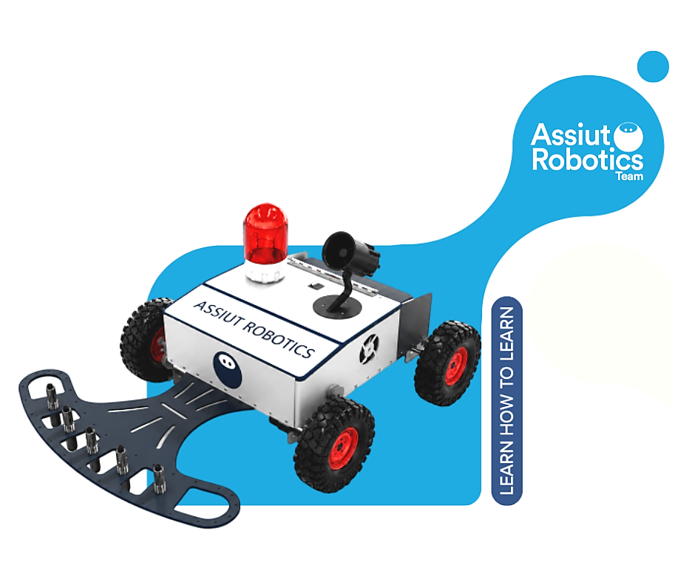
Assiut Robotics

Assiut University
Supervisor Dr. Mohamed Adelmoula
Academia Category
Eygpt
Abstract [Overview about robot/system] [250 words] (5 Points)
In aiming for a landmine-free world, our Minesweeper robot autonomously scans minefields, detects both surface and buried mines, maps their precise locations, and safely collects surface mines using electromagnetic grippers.
Built on a 2020 aluminum profile-X chassis with 1mm aluminum body panels, the robot combines strength and low weight to handle rough terrain. Four 27 kgf·cm DC geared motors paired with inflatable wheels provide reliable mobility across sand, mud, and uneven ground.
Localization relies on wheel encoders and an IMU for continuous odometry, corrected by a vision-based system: a camera on two servo motors reads field coordinate labels via OCR. Every detected mine (surface or buried) is automatically logged with its coordinate and type to build the final minefield map.
A Raspberry Pi 4 running ROS 2 serves as the robot's central controller, orchestrating sensor fusion, detection, and mapping across the entire mission.
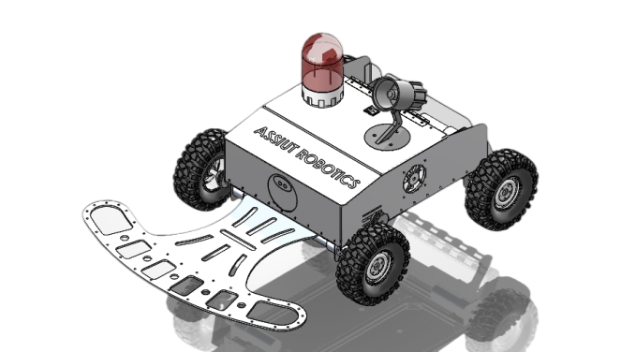
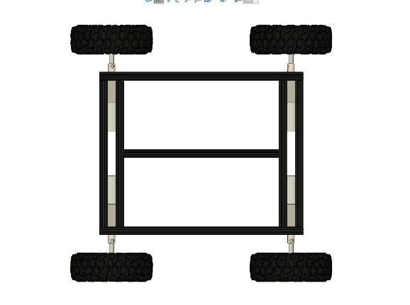

Describe your mechanical design and locomotion system [250 words + image] (10 Points)
Figure 2 our robot
Figure 1 chassis
The robot chassis was constructed using 20 × 20 mm aluminum profiles due to their excellent strength-to-weight ratio. This material provides a lightweight yet rigid structure capable of withstanding shocks and harsh operating conditions. The profiles were assembled using bolts and L-shaped corner brackets, which increased the structural strength and allowed easy maintenance and modification of the robot.
The outer body was fabricated from lightweight aluminum sheets to protect the internal electronic and mechanical components from external impacts and environmental conditions. Aluminum was selected because it is durable, corrosion-resistant, and adds minimal weight to the robot, improving its overall efficiency and mobility.
The robot employs a four-wheel-drive (4WD) locomotion system in which each wheel is powered by an independent DC geared motor. This configuration provides high traction, excellent stability, and improved maneuverability on rough and uneven terrain commonly found in minefields.
Each wheel is driven by a 12 V Brushed DC Geared Motor (LG45775/JGB37-500 series) with a power of 20 W, a maximum current below 4.2 A, a torque of 27 kgf·cm, and a speed of approximately 70 RPM. The selected motors provide sufficient torque to move the robot and carry all mounted subsystems while maintaining a low and safe operating speed for accurate mine detection.
This mechanical design results in a durable, lightweight, and reliable robotic platform capable of navigating hazardous environments efficiently and performing mine detection and collection tasks safely.

Describe the landmine disposal and marking mechanisms [250 words] (10 points)
For the disposal of surface mines, we designed an electromagnetic lift mechanism. The system consists of five electromagnets mounted on a moving arm driven by DC motor, with two limit switches at the upper and lower positions to control the arm's range of motion.
When a surface mine is detected, the lift arm descends toward the mine. The electromagnets are then activated, attracting and holding the metallic mine securely. The arm then lifts the mine upward and deposits it into a dedicated onboard container, keeping collected mines safely away from the robot's electrical components. The arm then returns to its initial position, ready for the next detection event.
This mechanism was chosen for its simplicity and reliability. Using electromagnets rather than a mechanical gripper eliminates the need for precise alignment with the mine, as the magnetic field can attract the mine even with slight positional offsets. The limit switches ensure the arm does not over-extend in either direction, preventing mechanical damage.
The use of five electromagnets distributed across the arm increases the effective pickup area, improving the probability of successfully collecting mines of varying sizes within the competition's specified dimensions of 5×5×5 cm.

Describe sensors and how can it detect landmines? [250 words] (10 Points)
The robot utilizes multiple sensors to support mine detection, localization, and navigation. The primary sensors include a metal detection circuit, a proximity sensor, an HD camera, wheel encoders, and an Inertial Measurement Unit (IMU).
Buried mines are detected using the metal detection circuit mounted at the front of the robot. When a metallic object is detected beneath the ground surface, the sensor generates a detection signal that is processed by the robot controller. Surface mines are detected using a proximity sensor, which identifies objects located above the ground within a predefined detection range.
The vision subsystem supports localization and mine mapping. An HD camera continuously captures images of the arena boundaries, where alphanumeric labels are placed. These labels are recognized using computer vision and OCR techniques, allowing the robot to determine its current position and associate detected mines with the correct arena coordinates.
To improve navigation accuracy, wheel encoders and an IMU are used together. The encoders measure the traveled distance, while the IMU provides orientation and heading information. This sensor fusion approach improves localization reliability during autonomous operation.
Whenever a mine is detected, the robot automatically activates a visual warning indicator and an audible siren in accordance with the competition requirements. Simultaneously, the mine location and classification are stored in the mapping database for later visualization.
The combination of detection, localization, and navigation sensors enables reliable mine identification and accurate minefield mapping throughout the mission.

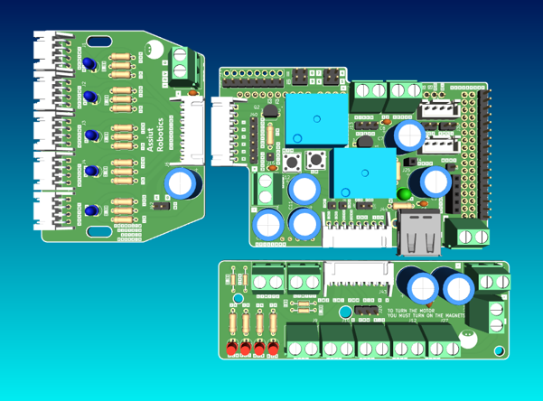
Describe your electronic circuit/control system/platform used [Teleoperated/Autonomous] [250 words + image] (10 Points)
Figure 3 PCB
The proposed robot is an autonomous mobile platform built around a Raspberry Pi 4 (8 GB) and an Arduino MEGA microcontroller. The Raspberry Pi performs high-level tasks including computer vision, localization, mine mapping, and ROS 2 execution, while the Arduino handles motor control and sensor acquisition. Communication between both controllers is established through serial communication, enabling reliable data exchange between the processing and control layers.
The robot utilizes a four-wheel differential drive system powered by DC motors and motor drivers. Wheel encoders provide odometry measurements, while an IMU supplies orientation and heading information. Additional sensors include a metal detection circuit for buried mine detection, proximity sensors for surface mine detection, and an HD camera used for arena coordinate recognition and localization. A warning LED and buzzer are automatically activated whenever a mine is detected.
To simplify wiring and improve maintainability, the electronic system is divided into three custom PCB modules connected through JST connectors. The Metal Detector Module interfaces with the metal detector, five proximity sensors, and status LEDs. The Lift Mechanism Module controls the electromagnets, DC motor, and limit switches used for mine collection. The Centralized Module is mounted directly on the Arduino MEGA as a shield and handles power distribution, sensor interfacing, and communication with the Raspberry Pi.

The software architecture is based on ROS 2, where dedicated nodes manage vision processing, localization, mine detection, navigation, and map generation. The robot operates autonomously using a lawnmower-style zigzag coverage strategy and automatically generates the final minefield map at the end of the mission.
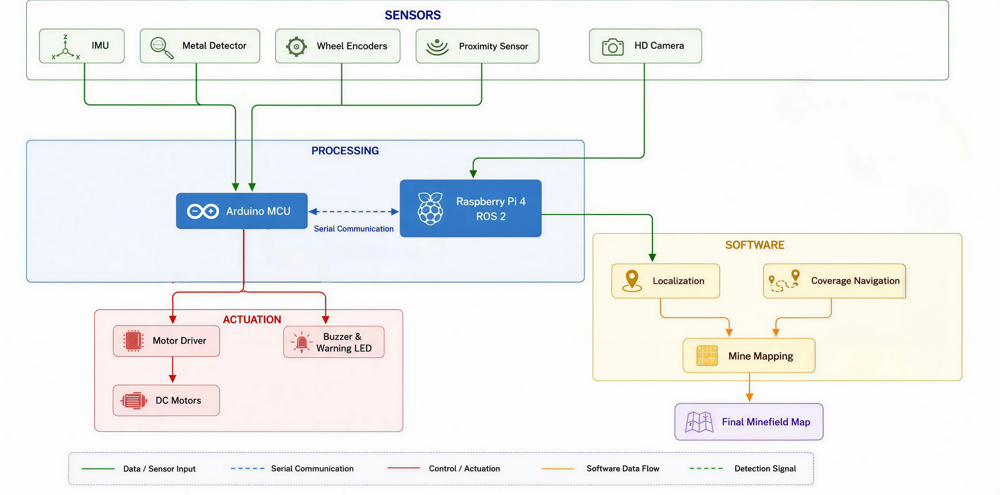
Figure 4 flowchart

Put your plan to navigate the whole arena [250 words] (10 Points)
The robot follows a systematic lawnmower coverage pattern to ensure complete exploration of the 20m × 20m minefield. Starting from one corner of the arena, the robot moves in straight parallel lanes across the field. Upon reaching a boundary, it performs a controlled turn and shifts to the adjacent lane before continuing in the opposite direction. This strategy minimizes missed areas and guarantees efficient coverage of the entire arena.
Navigation is primarily based on dead reckoning using wheel encoders and an IMU. The encoders provide traveled distance information, while the IMU supplies heading and orientation measurements. Sensor fusion is used to improve localization accuracy and reduce drift during long traversals.
The robot continuously scans the environment using its mine detection sensors while moving. When a mine is detected, the robot temporarily stops, performs the localization procedure, records the mine location, and then resumes its coverage path from the interruption point.
To handle rough terrain, the robot operates at a moderate speed and continuously monitors orientation changes using the IMU. Large deviations in heading are corrected automatically to maintain the planned trajectory. In the presence of obstacles, the robot performs a local avoidance maneuver and then returns to the nearest point on the predefined coverage path to continue the mission.
This navigation strategy provides reliable minefield coverage, efficient localization, and consistent mine mapping while maintaining a simple and computationally efficient implementation suitable for real-time operation on the robot platform.

Describe how to provide the map of detected mines? [250 words] (10 Points)
The robot automatically generates a digital minefield map throughout the mission. The map follows the competition format and represents the arena as a 19 × 19 grid, where columns are labeled from A to S and rows are labeled from 1 to 19. Each detected mine is associated with its corresponding coordinate and stored in a structured database.
The localization process relies on a vision-based system that recognizes the alphanumeric labels placed around the arena boundaries. When a mine is detected, the robot identifies its current coordinate and links it to the detection event. The resulting coordinate is then recorded in the map database together with the mine classification.
Mine classification is determined according to the sensor that triggers the detection event. Mines detected by the metal detection circuit are classified as buried mines, while mines detected by the proximity sensor are classified as surface mines. This information is stored alongside the mine coordinates to provide a complete representation of the minefield.
During operation, the map is continuously updated whenever a new mine is detected. At the end of the competition run, all recorded data are processed automatically to generate the final minefield map. The map is displayed through a custom graphical user interface developed using Python and OpenCV, where each mine is represented at its corresponding grid coordinate.
The final map is generated and presented automatically without human intervention, allowing the jury to easily verify the detected mine locations and classifications at the end of the allocated mission time.

How to face the rough environment and the high heat? [250 words] (5 Points)
Rough Terrain:
The robot's aluminum X-profile chassis provides high rigidity, preventing frame flex over uneven ground. The inflatable wheels (26cm diameter) naturally conform to surface irregularities, providing effective passive suspension without added mechanical complexity. The 27 kgf·cm motors ensure sufficient torque to climb inclines and push through soft sand or muddy patches without stalling.
The robot's lightweight design further helps on soft terrain, reducing the risk of sinking into sand or mud. Ground clearance is maintained by the wheel and chassis geometry to avoid the robot body dragging over rocks or raised terrain features.
High Heat:
The aluminum chassis and body panels act as passive heat sinks, dissipating heat more effectively than wood or plastic alternatives. The custom PCB includes dedicated mounting positions for heat-sensitive components away from heat sources, and the system design minimizes power dissipation in the control electronics.
To manage heat during operation, the robot is equipped with two cooling fans and a heat sink. The fans are triggered automatically when temperatures rise, ensuring critical components remain within safe operating limits throughout the full 20-minute competition run. The robot's enclosure also includes ventilation openings to allow continuous airflow across internal components.


Put your Video YouTube link here:
Link:
https://youtu.be/95lyZIP6ssU?si=EjzhzWdgWAbwXQHF
QR Code:

